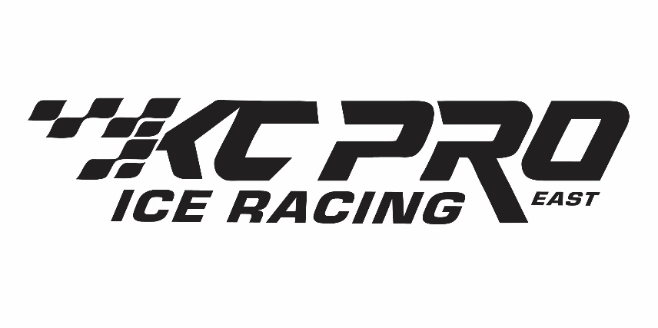

2027 KCPRO-EAST SPONSORSHIP REQUEST
Dear KCPRO-East Supporter,

KCPRO-East is a nonprofit 501(c)(3) youth snowmobile racing organization established in 1991. Our mission is to teach boys and girls ages 4–17 safe snowmobiling, good sportsmanship, and teamwork while providing a safe and family-friendly racing environment.
Our family-run organization serves racers and families throughout Northern Minnesota and Wisconsin. We offer ice-racing classes for young beginners through experienced racers.
KCPRO-East depends on the generous support of local businesses and our communities to help cover insurance, safety personnel, permits, awards, and other race-season expenses. We invite you to support our 2027 racing season through one of the sponsorship opportunities outlined on the following page.
In appreciation of your support, sponsors receive recognition through trackside signage, social media, our annual yearbook, website, and other promotional opportunities, depending on the sponsorship level selected.
Please submit sponsorship commitments and payments by December 15, 2026, to allow time for printing before the start of the season.
On behalf of our officers, families, volunteers, and racers, thank you for supporting KCPRO-East and the young racers in our communities!

Matt Holmes
President | (218) 780-3099
Sponsorship & Fundraising:
Stacy Kuusinen, Fundraising Committee Chair | (218) 969-0167

2027 SPONSORSHIP LEVELS

LEGACY SPONSORSHIP — $2,500+
- Trackside sign displayed at all race events
- Advertising sticker on the KCPRO-East Try Me Sled
- Featured recognition post on the KCPRO-East Facebook page
- Logo and website link on our sponsors webpage
- VIP recognition at our end-of-season banquet
- Priority logo placement at all sign-in locations
- Full-page advertisement in our annual yearbook
- Business name engraved on KCPRO-East travel mugs

PLATINUM SPONSORSHIP — $1,000+
- Trackside sign displayed at all race events
- Logo and website link on our sponsors webpage
- Spotlight appreciation post on Facebook
- Business name engraved on KCPRO-East travel mugs
- Half-page advertisement in our annual yearbook

GOLD SPONSORSHIP — $500+
- Trackside sign displayed at all race events
- Quarter-page advertisement in our annual yearbook
- Logo and website link on our sponsors webpage
- Spotlight appreciation post on Facebook

SILVER SPONSORSHIP — $300+
- Trackside sign displayed at all race events
- Business-card-size advertisement in our annual yearbook
- Logo and website link on our sponsors webpage
- Group recognition post on Facebook

RACE SPONSORSHIP — $100 PER RACE
- Sponsor one or more races of your choice.
- Thank-you listing in our annual yearbook
- Website link on our sponsors webpage
- Race sponsor recognition on Facebook
- Recognition announcement during the awards ceremony

SUPPORTING DONATION — ANY AMOUNT
Want to support our youth racers without promotional recognition? We gratefully accept donations of any amount.

2027 KCPRO-EAST SPONSORSHIP FORM
SPONSOR NAME:

SPONSOR ADDRESS:

CONTACT NAME & PHONE NUMBER:

EMAIL ADDRESS:

BUSINESS WEBSITE:

LOGO AVAILABLE? ☐ Yes ☐ No
If yes, please email your logo to kcprosecretary@yahoo.com.

SELECT SPONSORSHIP LEVEL
☐ Legacy — $2,500+
☐ Platinum — $1,000+
☐ Gold — $500
☐ Silver — $300
☐ Race Sponsor — $100 per race
☐ 1 Race ☐ 2 Races ☐ 3 Races
☐ Supporting Donation — Any Amount $________________
PAYMENT
Please send sponsorship forms and payments by December 1, 2026, to allow adequate time for printing and proper recognition at all races.

Mail checks to: PayPal:
KCPRO-EAST Visit www.kcproeast.com/becomeasponsor
c/o Sophie Anderson
5371 McQuade Road
Duluth, MN 55804

2027 KCPRO-EAST RACE DATES & LOCATIONS

We hope you can join us at one or more of our 2027 season races! The following dates and locations are tentative and subject to change.

DATE | LOCATION | CITY
January 2 | Pelican Lake | Orr, MN
January 9 | Fall Lake | Ely, MN
January 23 | Location Pending | —
January 30 | Myrtle Lake | Orr, MN
February 6 & 7 | Pike Lake | Duluth, MN
February 21 | Swan Lake | Pengilly, MN
February 22 | Tentative Race Make-Up Day | —
February 27 | Lake Vermilion | Cook, MN

Race dates and locations may change due to ice conditions or hosting considerations. Please follow KCPRO-East on Facebook or visit our website for the most up-to-date race information.

